REPORT

TASK 2

# Task 2

UML Class Diagram

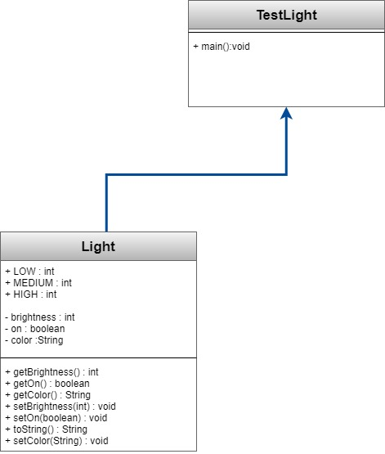

Output screenshot

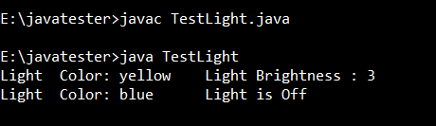

Logic Explanation

* To solve the problem, I have created two classes Light.java and TestLight.java
* In that Light.java class there are three final variables to store the status of light brightness
* In the constructor the default light is created by assigning the default values to the data fields declared which are brightness, on, color.
* A tostring() method is created to return the status of light in string form.
* In TestLight two objects are created and values are set for the required attribures, and toString() method for each of them is invoked